DOCTOR (ADD YOUR SPECIALITY & OTHER INFORMATION)
Doctor Contact Information
Send your Profile to ramesh_vis@hotmail.com, ramesh@utrustus.org

ABOUT DOCTOR
Dr Full Name
Gender
Education Qualification
Experience
Speciality
Country
City
Consulting Languages
Photo (Optional)
Video Profile (if any)

Doctor Contact Information

CONTACT DETAISL (MOBILE, EMAIL – We don’t publish for Public)
Mobile Number
Office Number
Emergency Number
Personnel Email Address
Official Email Address
Hospital Name
Hospital Profile
Hospital Address
Location
Personal Website
Hospital Website

Doctor Contact Information

DOCTOR PROFILE & AWARDS etc.,
About Doctor
Other Certification
Other Services
Dr Own Products (if any)

Doctor Contact Information
DOCTOR OTHER INFORMATION
Additional Information
Other Information
Awards & Achievements

Send your Profile to ramesh_vis@hotmail.com, ramesh@utrustus.org

Doctor and Hospital details will reach to A to Z Countries
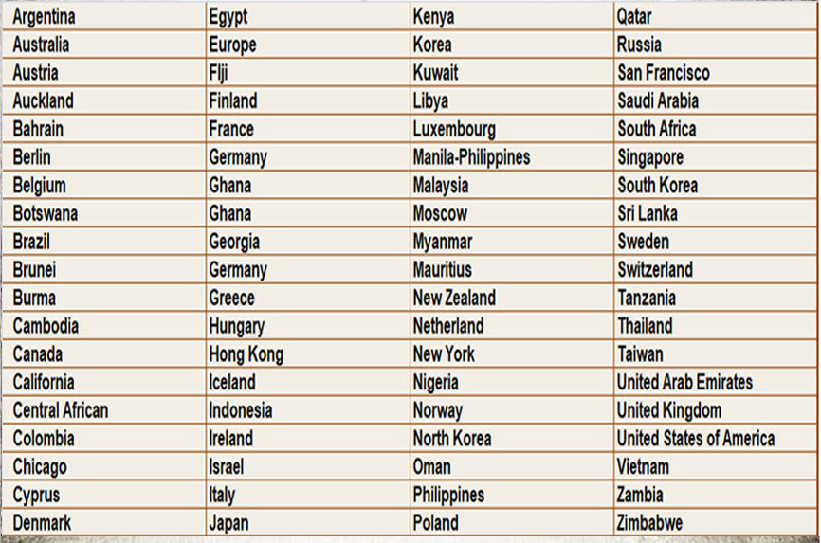

Doctor’s & Hospital’s Profile will be sent via Email, Whatsapp, Social Media
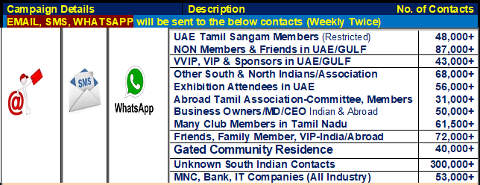

HOW IS THIS PLATFORM GOING TO HELP DOCTOR & HEALTHCARE?
- Trustable Platform to all Healthcare & Entrepreneurs
- Taking Healthcare Experts, Products & Services to the World
- Branding, Promotion about the Doctor to the World (70+ Countries, 170+ Tamil Sangam)
- Hospital’s Branding, Promotion Abroad & India (70+ Countries, 170+ Tamil Sangam)
- On-Line Promotions, Branding & Marketing, Social Media
- Web Banner about Doctors & Hospitals details on UTS Websites
- Achievement Video & Photos will be publish on our Websites
- Medical Tourism Support (Indians and other Nationalities)
- Refer Patients (Indian & other Nationality) direct to Hospital or Doctor
- Exclusive Web-Page on UTS Healthcare Directory about Doctor & Hospital complete Information.
- Email & Whatsapp Campaign (Entire Members, NON Members, Friends) India & Abroad
- A4 Page Full Page Advertisement E-Magazine Doctor, Hospital details will be distributed everyone via Email & Whatsapp

UTS IS UNIQUE IN (U TRUST US OTHER ACTIVITIES)
- Medical Camp, Medical Excellence Award
- Healthcare Delegates Meet
- Opportunity for Doctors, Nurses and Hospital with Abroad Health Care Team
- Indian Medical University student's Internship at Abroad Hospital via Local Health Team/Academy
- Indian Medical Students appointment in Abroad Hospitals
- Job Opportunity for Doctors, Nurses and Healthcare Team in Abroad
- Medical Tourism, Hospital Tie-up

Ramesh Viswanathan
Chairman, MD - UTS Group
Founder & President UTS- UAE Tamil Sangam, Dubai
Founder UTS - Ulaga Thamizhargalin Sangamam

Ramesh Viswanathan
UAE Tamilians Directory (Referral Book for Gulf Tamilians)
Managing Editor and Director
Who’s who of UAE Tamilians, Qatar Tamilians, Kuwait Tamilians, Oman Tamilians, Saudi Arabia Tamilians, Bahrain Tamilians
Mobile and Whatsapp : Dubai +971505865375, India +91-9176966014
ramesh_vis@hotmail.com, ramesh@utrustus.org
ramesh@gulftamilsangam.com
WEB: www.utrustus.org / www.gulftamilsangam.com

